Why do I need a resume? | The average amount of time an employer takes to initially review an applicant’s resume is 15-45 seconds. You want to be sure yours is ready to go and stands out!  Resumes can be used for employment and the following:  - Volunteer positions  - Scholarship applications  - Activity lists for college applications  - Internship applications  - Apprenticeships
- Log into Naviance | 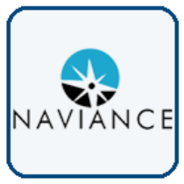  Username: district ID#  Password: district password
- Naviance Resume Builder tool will help you create a custom resume to download/print in multiple formats.  Click your initials in upper-right corner.  Click Resume link | 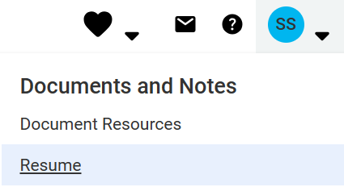
- Consider these resume tips as you create/update your resume. | - Use action verbs  - Use short, concise statements  - Keep resume to one page (if possible)  - Include only relevant information  - Easy to read format
- Start with your Education. Use your current school and list any other high school attended.  Click Add when complete.  *Note: Fill in the required sections with the red asterisk. (*) |       (*Automatically included in your Naviance account & can be edited when exported.)
- Next add Work Experience. | 
- Options for adding additional sections to your resume.  You will be able to choose which information to include in your resume prior to downloading.  (*Contact Information automatically included in your Naviance account & can be edited when exported.) | 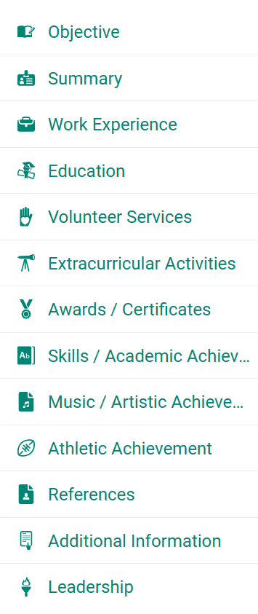
- When complete, you will print/export your resume from the Resume Builder tool to upload to the task.  Click Print/Export Resume, next:  - Click plus icon  - Type a name for the resume  - Choose your template  - Click Continue | 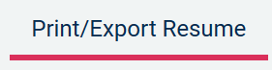  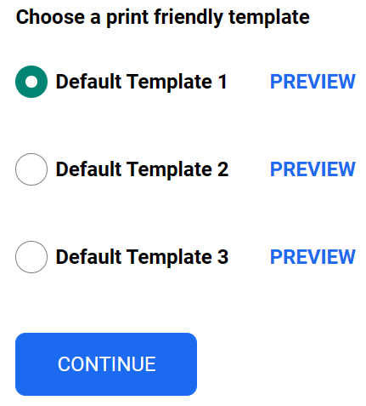
- Select the sections to include in your resume and click Save Resume.  You can print/save your resume as a .PDF or .Docx |     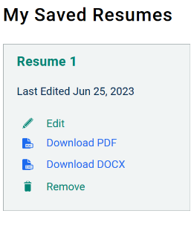  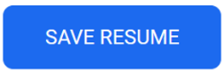
- Task Completion: | Click the title of the task, Upload Completed Resume. Click Browse… to locate your resume and upload it to the task.

